ShadowMega RADZ  
Drilling Instructions

02/04/2022

# Preparations

## Assemble the two Case Shells

|  |  |
| --- | --- |
|  | As the first step, we need to put the two case shells together and fix it in place with some M4 screws. If your printer is already assembled, remove all the parts from the frame. The goal is to have a sturdy frame that we can drill into without deforming parts of it. |

## Screw Shells together

|  |  |
| --- | --- |
|  | If the Case is already put together, you can either choose to keep it that way or drill out the rivets and replace them with M4 x 6mm countersunk screws with hex nuts. Do not tighten any of the nuts until all the screws are in place. If your case is still unassembled, use M4 x 6mm countersunk screws with hex nuts along the top, the front edge, and the bottom to fix the two shells in place. Do this on both sides. At the back, use 4 x M4 x 8mm pan head Screws with hex nuts to fix the back radius in place. Make sure the case is squared up and start tightening the screws. Start with the four pan head screws in the back, tightening them from the edge of the case inwards. Then tighten the screws in the side corners while making sure the case is still square. After that, tighten all the other screws. Verify once more that the case is square. |

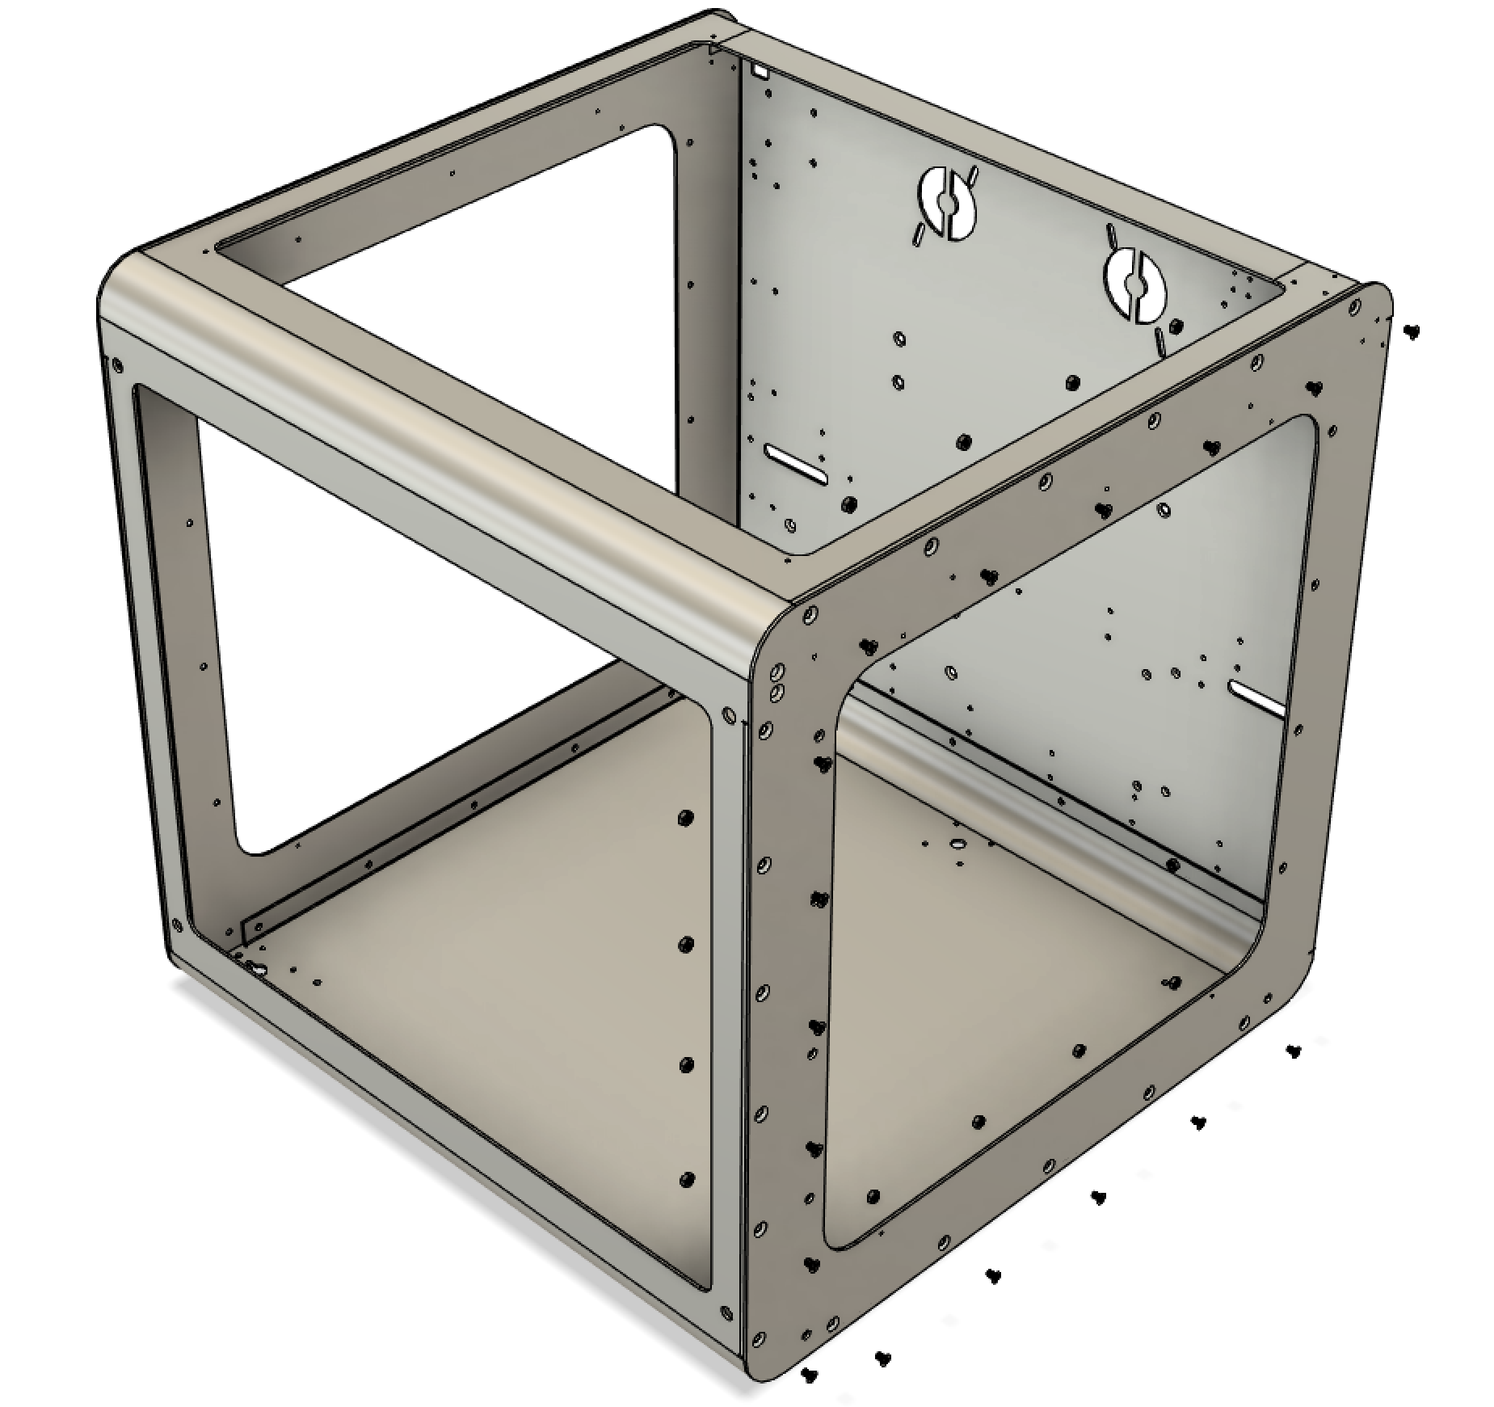

# Drilling Instructions

|  |  |  |  |  |  |  |  |  |  |  |  |
| --- | --- | --- | --- | --- | --- | --- | --- | --- | --- | --- | --- |
|  | When drilling through the templates, make sure you hold the drill as perpendicular to the case as possible. Use high drill speed and drill with one quick push. Try not to ream out the template too much.  All drill sizes in this document are specified in metric units and those sizes are preferred. Here is an imperial substitution list if metric drills are not available, but, you might run into some issues either drilling or with the location of the hole.   |  |  | | --- | --- | | Metric Drill Size | Imperial Drill Size | | 3.5mm | **9/64** (3.5719mm) or **1/8** (3.175mm) | | 4.5mm | **11/64** (4.3656mm) or **3/16** (4.7625mm) | | 5.5mm | **13/64** (5.16mm) or **7/32** (5.55625mm) | | 13mm (12mm works as well) | **1/2** (12.7mm) | |

# Drilling

## Drill Front Stepper Holes

|  |  |
| --- | --- |
|  | The first set of holes to drill are the front stepper holes. For that, screw the front stepper template to the outside of the case with two M4 x 30mm countersunk screws with a hex nut on the inside of the case. Once the template is solidly fitted on the case, drill through the empty holes, expect for the ones marked with red X below.   * Drill the four 4.5mm holes around the bigger center hole * Drill the 13mm center hole * Drill the two 5.5mm holes towards the center of the case.   Unscrew the template, rotate it 180deg and mount it on the opposite front corner. Repeat the same drill order as with the first corner. |

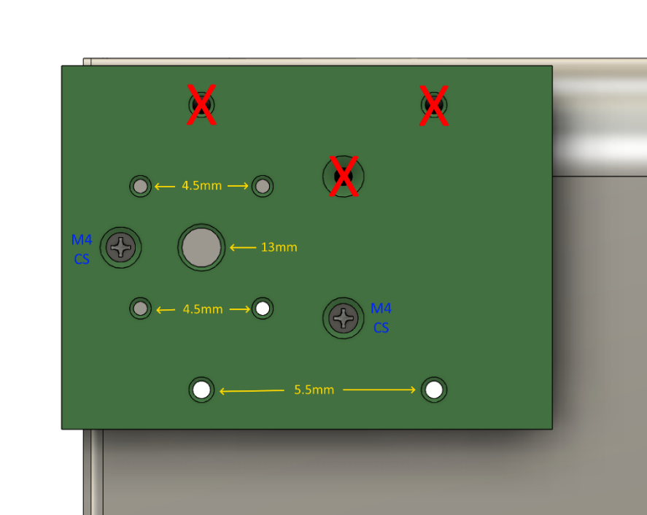

## Drill Front Floor Holes

|  |  |
| --- | --- |
|  | Screw the floor template on from the outside of the case using two M4 x 30mm countersunk screws with hex nuts on the inside of the case.   * Drill through the two inner holes with a 5.5mm drill. |

## Drill Back Side Holes

|  |  |
| --- | --- |
|  | Screw the back side template to the outside of the case with two M4 x 30mm countersunk screws with a hex nut on the inside of the case. Once the template is solidly fitted on the case, drill through the empty holes, expect for the ones marked with red X in the diagram for the front stepper holes.   * Drill the two 5.5mm holes towards the center of the case.   Unscrew the template, rotate it 180deg and mount it on the opposite front corner. Repeat the same drilling as with the previous corner. |

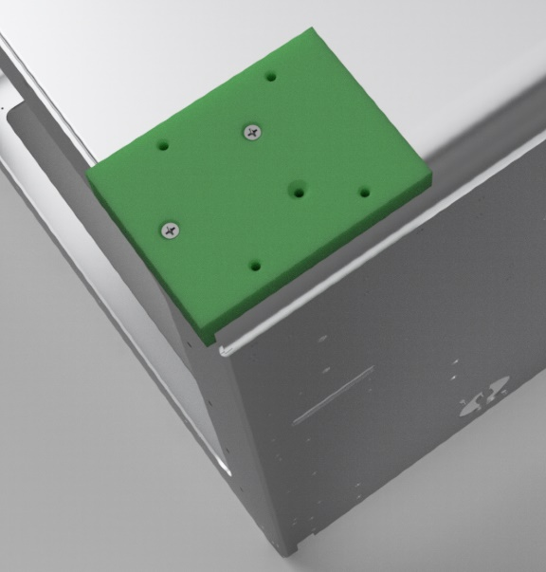 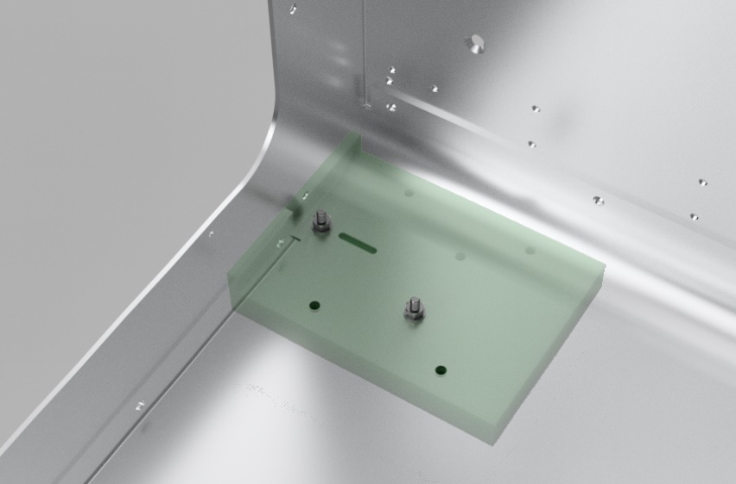

## Drill Back Floor Holes

|  |  |
| --- | --- |
|  | Screw the floor template on from the outside of the case using two M4 x 30mm countersunk screws with hex nuts on the inside of the case.  Drill through the two inner holes with a 5.5mm drill. |

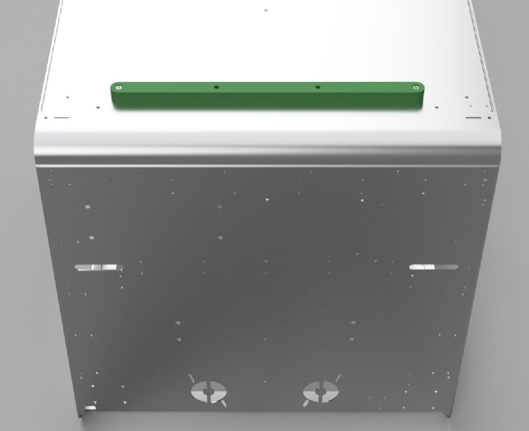

## Drill Back Stepper Holes

|  |  |
| --- | --- |
|  | Screw the back stepper template onto the case using two M4 x 30mm countersunk screws on the bottom, two M4 x 30mm countersunk screws on the lower end of the backwall and four M3 x 25mm (or longer) on the back wall.  The first set of holes to drill are the front stepper holes. For that, screw the front stepper template to the outside of the case with two M4 x 30mm countersunk screws with a hex nut on the inside of the case. Once the template is solidly fitted on the case, drill through the empty holes, expect for the ones marked with red X below.   * Drill the four 4.5mm holes around the bigger center hole * Drill the 13mm center hole * Drill the 4.5mm hole in the horizontal center of the back wall. |

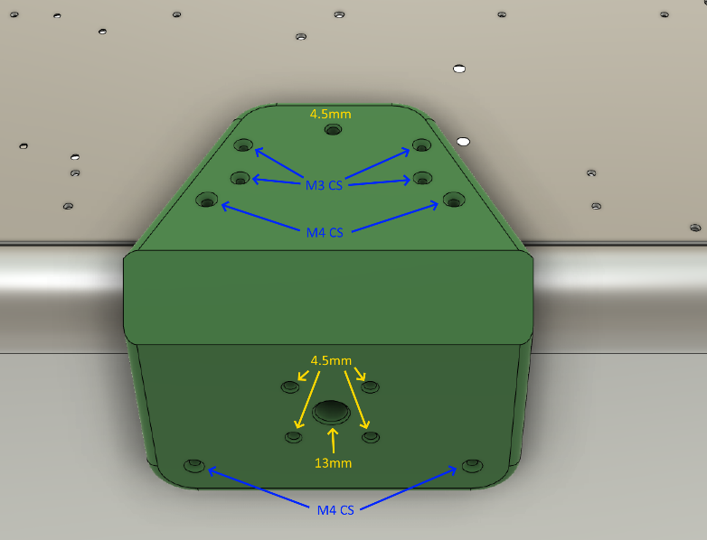

## Drill Back Wall Holes

|  |  |
| --- | --- |
|  | First part doesn’t require a template as we are just drilling existing M3 holes out to 4.5mm. See the graphic below on which holes to drill out. |

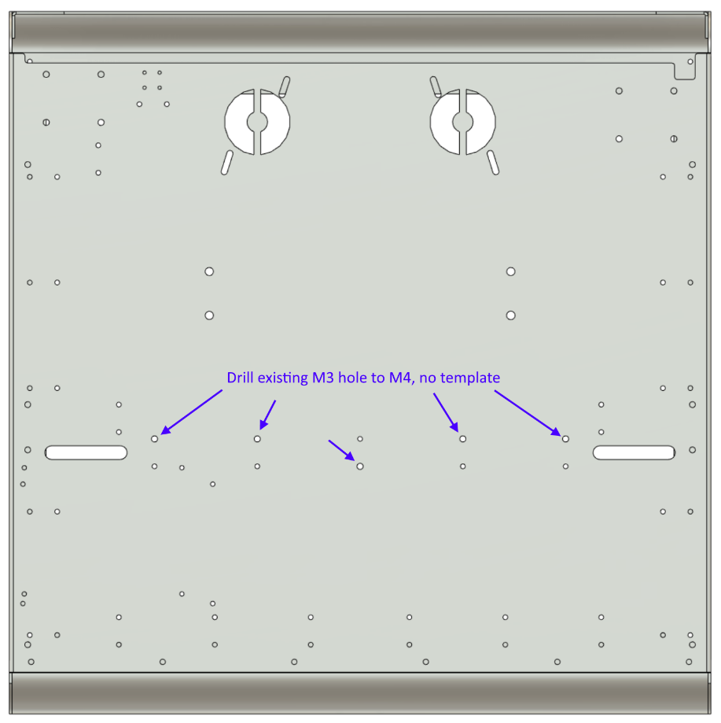

|  |  |
| --- | --- |
|  | For the second part of the back wall drilling, mount the back brace as shown in the diagram below.   * Drill the two 4.5mm holes down the center |

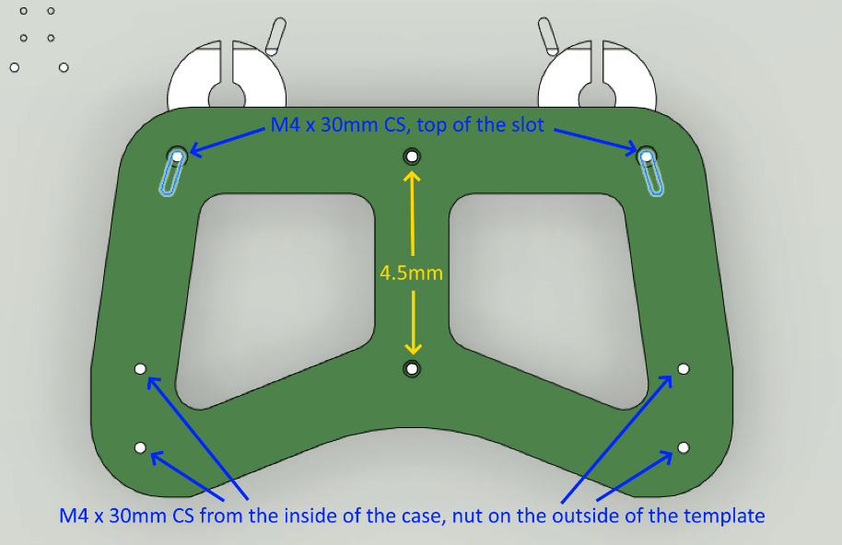

## Drill Fanless PSU Holes

|  |  |
| --- | --- |
|  | Screw the two PSU drill templates onto the case using the screws shown below.   * Drill the four 4.5mm holes as indicated below |

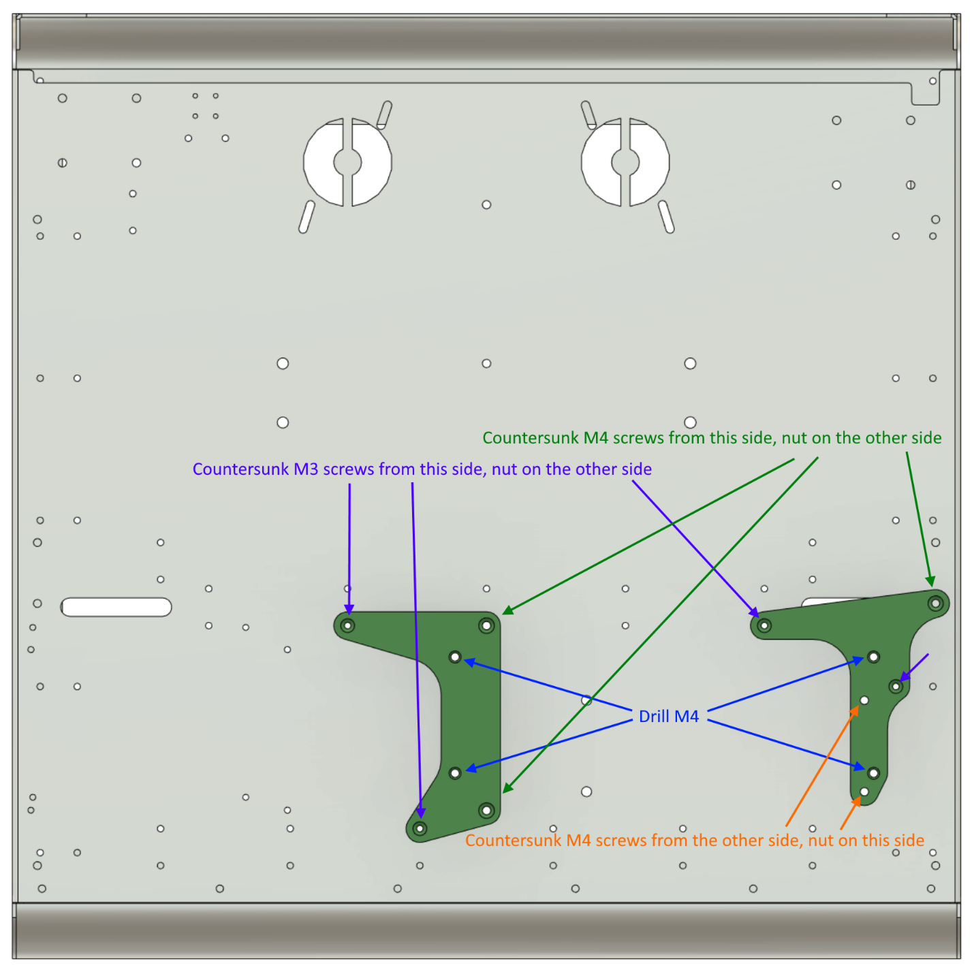

## Drill Side Rails Holes

|  |  |
| --- | --- |
|  | Screw the side rail templates onto the case using six M3 x 25mm (or longer) countersunk screws onto the side of the case. The two screw goes into one of the threaded holes for the Y rail, the others have nuts on the inside. Make sure the templates are as vertical as can be. Pay attention to the Arrow pointing up on the lower template.   * Drill the two 3.5mm holes in the upper template * Drill the three 3.5mm holes in the lower template |

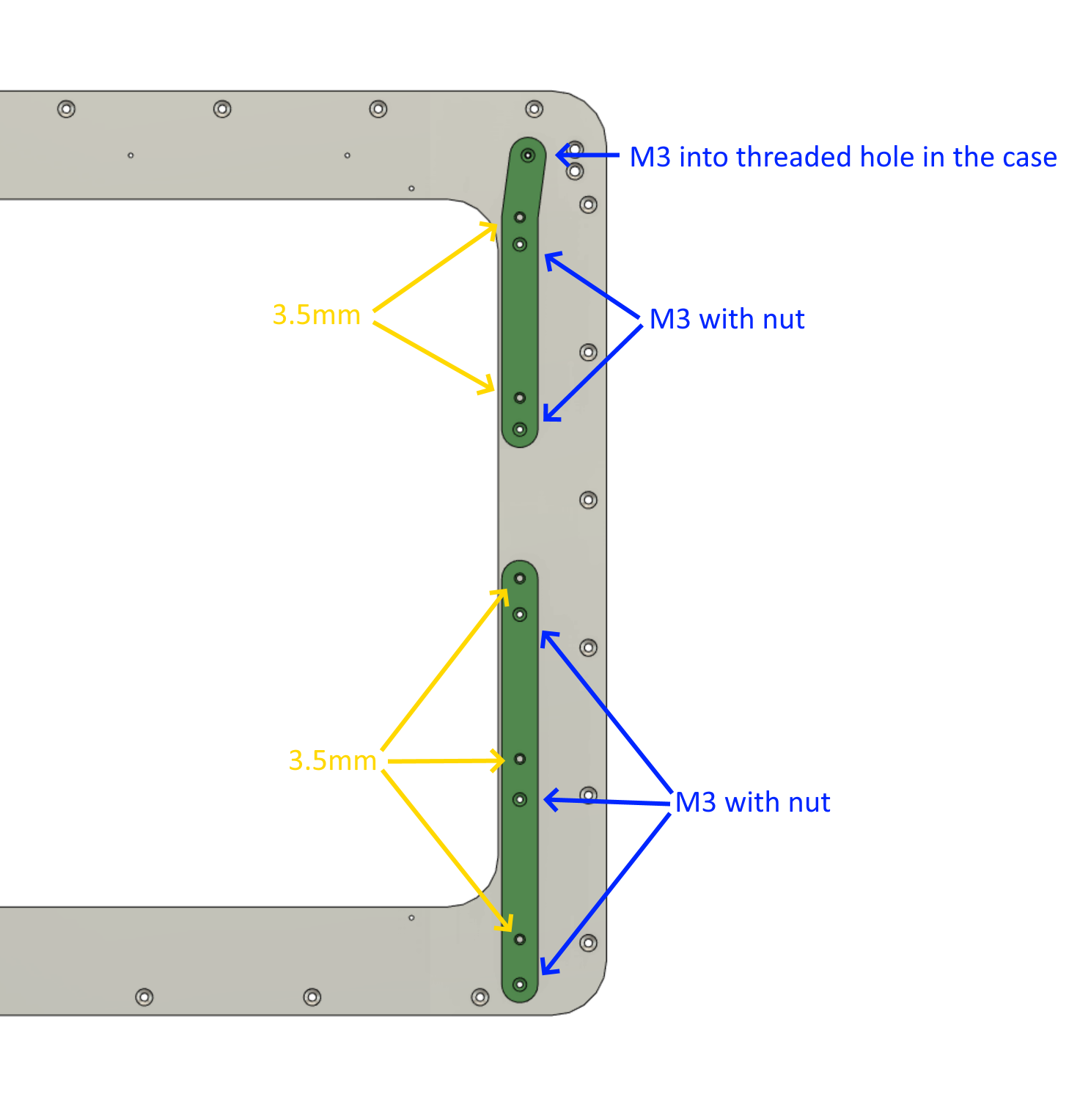

## Drill Front Idler Holder Holes

|  |  |
| --- | --- |
|  | Screw the front idler holder template onto the case using two M4 x 14mm countersunk screws from the side and an M3 x 25mm (or longer) from the front wall. Each screw is fastened on the inside with a hex nut that is on the corresponding counter plate. Fasten the three screws only loosely. Once they are all in place and hold the template in position, tighten the side screws first and then the front screw.   * Drill the 3.5mm hole from the front |

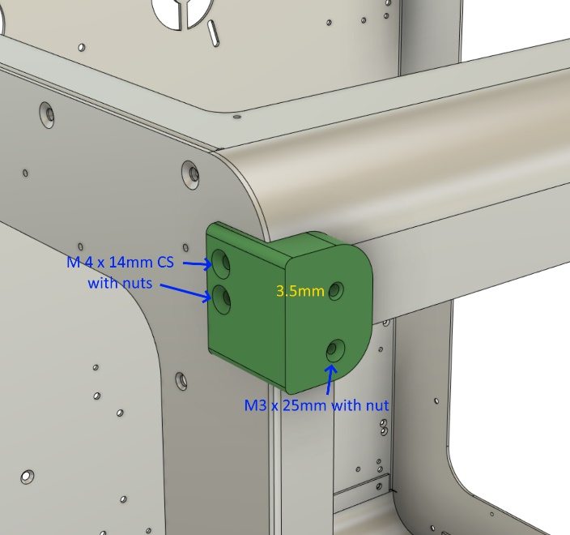 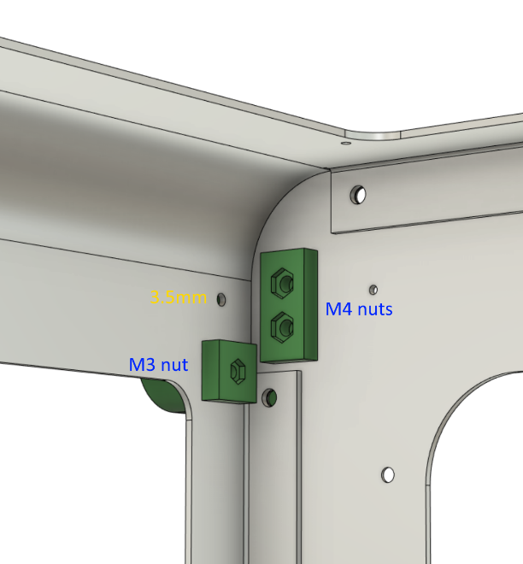

## Final Processing

|  |  |
| --- | --- |
|  | Make sure all the holes are deburred either with a larger drill bit or with a deburr tool. |